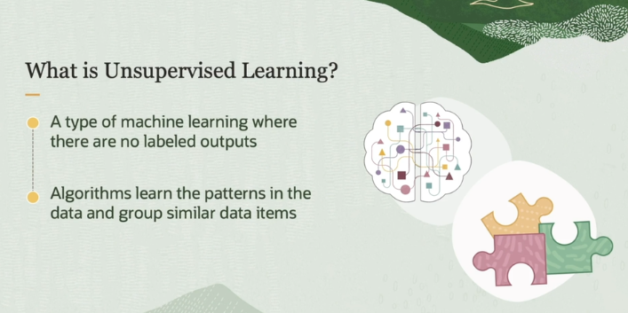

Unsupervised machine learning is a type of machine learning where the algorithm learns from data that doesn't have any labels or predefined categories. It's like exploring a new place without a map—no one tells the algorithm what to look for, but it still tries to find patterns and relationships in the data.

Imagine you have a pile of LEGO pieces in front of you. They come in different colors, sizes, and shapes, but no one tells you how to sort them. If you look closely, you might notice that some pieces are the same color, some are the same size, and some have similar shapes. Based on what you observe, you could group all the red pieces together or all the large pieces together. You weren’t given instructions on how to group them, but you found patterns and organized the LEGO pieces by yourself.

That’s exactly what happens in unsupervised learning. The algorithm doesn’t know what to look for but discovers patterns in the data and groups similar data points together based on those patterns.

For example, think about a basket filled with apples, bananas, and oranges. No one tells you what types of fruit you have, but you notice some are round and red (apples), others are long and yellow (bananas), and another group is round and orange. You group the fruits based on these similarities without anyone telling you how. This grouping is a simple form of unsupervised learning.

In summary, unsupervised learning is all about letting the algorithm explore the data on its own and group similar items together without specific guidance. It helps in tasks like clustering and finding hidden patterns in data.

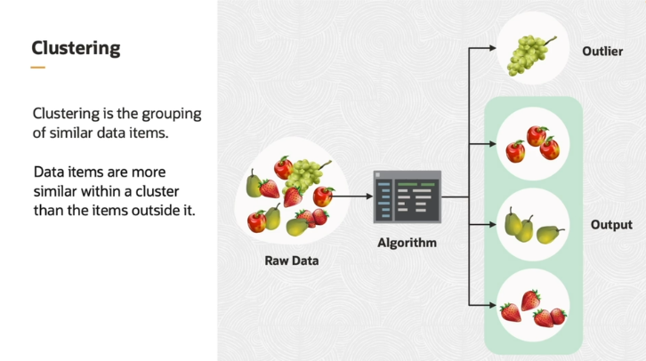

Clustering is a technique in unsupervised machine learning where we group data items based on how similar they are to each other. The idea is to organize data in such a way that items within the same group (called a **cluster**) are more alike than those in different groups.

Think of clustering like organizing a drawer of mixed items. Imagine you have apples, pears, strawberries, and grapes. If you're clustering them, you might group the apples, pears, and strawberries together because they are similar in shape, size, or color—perhaps they're round or of a similar size. Grapes, on the other hand, are much smaller and have a different shape compared to the other fruits, so they might not fit well into any of the main clusters. In this case, grapes could be considered an **outlier**.

An **outlier** is something that doesn’t belong to any of the groups because it’s too different. It’s like finding an unexpected item in your organized drawer—something that stands out and doesn’t fit with the rest.

In clustering, the goal is to form clusters where the items inside each group are similar to each other. If something is too different from all the other groups, like the grapes in our example, we call it an outlier. This method helps us understand patterns in the data by identifying groups and things that stand out.

The first use case of unsupervised machine learning is market segmentation. In market segmentation, one example is providing the purchasing details of an online shop to a clustering algorithm. Based on the items purchased and purchasing behavior, the clustering algorithm can identify customers based on the similarity between the products purchased. For example, customers with a particular age group who buy protein diet products can be shown an advertisement of sports-related products.

Now in above example simply yeh ho rha hai kay ab like humara ek online store hai or usme humay customer segmentation krni hai toh ab humay nhi pta kay kis type kay customers humara store par aa rhay hain or kiu kay huma pta hi nhi hai kay kis type ka customer humaray pass aa rhay hain toh iss lia hum **supervise ml** toh use nhi krsktay bcuz usme toh label data provide krna hota hai , toh in that case we will **unsupervised ML** bcuz here we want to find type of customer on the basis of given dataset, so then it will create groups/clusters of similar type of customer so then we would know that which type of customer we have and their quantity.

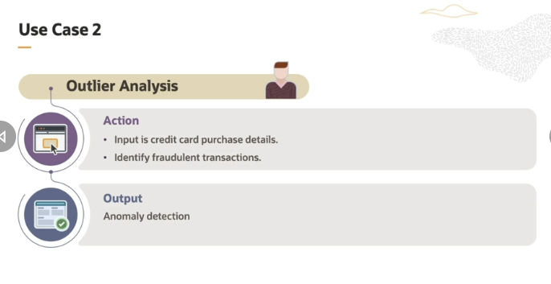

The second use case is on outlier analysis. One typical example for outlier  analysis is to provide credit card purchase data for clustering. Fraudulent transactions can be detected by a bank by using outliers. In some transaction, amounts are too high or recurring, it signifies an outlier. Now its mean that jo normally transaction method or mechanism hain unka data model ko provide krdein then model un transactions mechanisms ko category ma divide krkay clustering/grouping krlay . then phr agar later on in future agar koi asi transaction ho jo unma say kisi transaction group/category ma lie nhi kr rhi toh that will be known as **outlier** which means kay waha model detect krlega kay pehla koi asi transaction nhi hui toh isi lia wo usko as a farudlent detect krega.

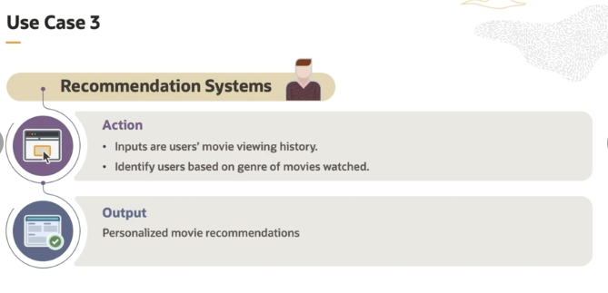

he third use case is recommendation systems. An example for recommendation systems is to provide users movie viewing history as input to a clustering algorithm.

It clusters users based on the type or rating of movies they have watched. The output helps to provide personalized movie recommendations to users. For example, Netflix. The same applies for music recommendations also. Now yaha be yehi same ho rha hai kay if we want to create recommendation system toh usme Zahir hai pehlay humaray pass categories/cluster/group of users honay chaiya then we can recommend them , So yaha be yehi ho rha hai kay **clustering algo** ka through it will cluster the types of user then recommend them.

Q- i have understood that in supervise Ml we provide label data and in unsupervise ML we dont provide, But now the question is that what are that task where i cant use supervise Ml and where i can use unsupervised ?

**Supervised Learning (Labeled Data)**

You use **supervised learning** when:

* **You know exactly what you want to predict or classify.**
* You have a **clear set of labeled data** (meaning you already know the correct answers).

Here are examples of tasks where supervised learning is the best choice:

1. **Email Spam Detection**: You have emails labeled as "spam" or "not spam." You train a model to learn from these labeled emails and predict whether new emails are spam or not.
2. **House Price Prediction**: You have past data on house prices (the labels) along with features like size, location, and number of rooms. You can train the model to predict prices for new houses based on this labeled data.
3. **Image Classification**: You have a dataset of images with labels like "cat," "dog," or "bird." The model learns from these labeled images and classifies new ones into those categories.

In supervised learning, you need labels for every piece of data to teach the model what the right output is.

**Unsupervised Learning (Unlabeled Data)**

You use **unsupervised learning** when:

* **You don’t have labels.**
* You just want to explore the data to find hidden patterns, groups, or anomalies.

Here are examples of tasks where unsupervised learning works better:

1. **Customer Segmentation**: Imagine you run an online store and have data about customers (their purchases, browsing behavior, etc.), but you don’t know in advance what type of customers you have. Using unsupervised learning (clustering), you can group similar customers together based on their behavior (e.g., frequent shoppers, occasional buyers, bargain hunters, etc.). This helps with personalized marketing, but there are no predefined "labels."
2. **Anomaly Detection**: Let’s say you’re monitoring network traffic for security. Most of the traffic is normal, but sometimes there’s suspicious behavior (like a cyber attack). Using unsupervised learning, you can detect this unusual activity as an **outlier** without having labeled data.
3. **Market Basket Analysis**: You own a supermarket and want to find patterns in customer purchases. You don’t have labels for the products customers will buy together, but unsupervised learning can help discover groups of products frequently bought together (like bread and butter), without any prior labels.

**When You Can’t Use Supervised Learning:**

* **No labels**: If you don’t know the correct answers (like customer groups or hidden patterns in data), you can’t use supervised learning because you don’t have labeled data to train on.
* **Exploratory Tasks**: When the goal is to explore the data to see what patterns or groups emerge, unsupervised learning is the way to go.

Q- But isme ek question yeh haka ab jasay agar customer segmentation krni hai toh wo toh supervise Ml kay through be hoskti hai like wegive input feature to model and unme kuch feature define krdein like searching data, favourite product etc or uskay corresponding label assign krdein like agr searching data may user mostly sports related product kr rha hai toh uskay sth sports ka label lgadia and isi tarah kay dataset pa training krkay model ko supervisely learn krwa skaty hain ?

Your thinking is on the right track, but let's clarify where supervised and unsupervised learning fit in customer segmentation. You're right that you **can** use supervised learning for customer segmentation **if** you have predefined labels, but in many real-world cases, these labels don’t exist.

**Supervised Learning in Customer Segmentation (What You Described):**

In the scenario you described:

* You **manually define labels** like "sports shopper," "electronics shopper," or "fashion shopper" based on customer behavior (like searching for sports-related products).
* You **train a model** using these labeled examples so it can later classify new customers into these predefined segments.

This approach works **if you already know** the types of customers you want to segment and can create a labeled dataset. For example:

* **Input Features**: Search data, favorite products, browsing time.
* **Labels**: "Sports Enthusiast," "Gadget Lover," "Fashion Shopper."

In this case, yes, you can use **supervised learning** because you're telling the model what to learn based on labeled data you provide.

**Why Unsupervised Learning is Often Used for Customer Segmentation:**

However, in **most cases**, you don’t start with predefined labels. You don’t know in advance what types of customer groups exist. The data is unlabeled, and you’re using clustering techniques to **discover hidden groups** on your own.

* With **unsupervised learning**, the algorithm finds patterns in the data and groups similar customers together based on behavior without needing any labels. The model might find customer segments you didn’t expect, like a group that buys both sports and fashion products, which you might not have thought of as a label.

**When to Use Supervised vs. Unsupervised for Customer Segmentation:**

* **Supervised Learning**: Use it when you **already know the segments** you want and can assign labels (like "sports shopper" or "tech enthusiast").
* **Unsupervised Learning**: Use it when you **don’t know the segments** yet and want to discover them from the data (e.g., finding hidden customer groups based on purchasing behavior without predefined labels).

So in simple terms jab humay nhi pta kay kis type ka data hoskta hai or koi categories/group/cluster be nhi hain toh in that case we will use **Unsupervise** BUT jasay agr humay pta hai kay kis type kay customers hainn humaray pass so then we can go for **supervise** but usme phr be limitations ajati hai bcuz day by day you are getting new customers of different types so how you will label them , therefore best approach is to use **unsupervised.**

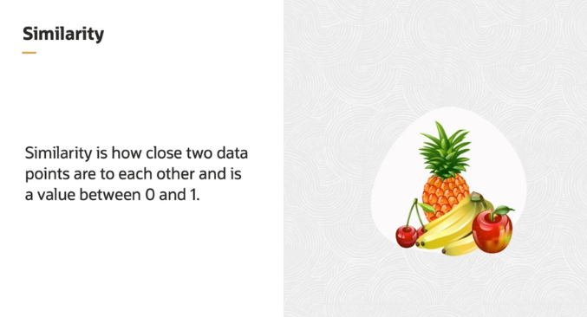

**Concept of Similarity**

In unsupervised learning, **similarity** is key. It's about figuring out how similar or close two data points (objects) are to each other. This similarity is measured on a scale from **0 to 1**, where:

* **1 means the objects are very similar** (almost the same).
* **0 means the objects are completely different**.

**How Similarity Works in Clustering:**

When you group items using **clustering**, the similarity between objects decides which **cluster** they will be placed in. Objects that are more similar to each other will be grouped together.

For example, imagine you have a basket of fruits, and you want to group similar fruits together. If you base similarity on **color**, you might put **apples** and **cherries** in the same group because they are both red. Since they have a similar color, their similarity score would be closer to **1**. On the other hand, if you compare an apple to a banana, their similarity score would be closer to **0** because they are different in color.

**Types of Similarity Measures:**

There are different ways to calculate similarity, depending on the type of data and how you want to measure it. Some methods compare shapes, colors, or even distances between data points. In clustering, this helps the algorithm decide which items go together.

**Steps in Unsupervised Learning and Using Similarity:**

1. **Choose Features**: First, you decide what features to focus on (e.g., color, size, shape of fruits).
2. **Measure Similarity**: You calculate how similar each pair of items is, using a similarity metric (like comparing colors or distances). Iska mtlb haka ek way btana kay kis tarah similarity define krni hai and it depends on data.
3. **Group Based on Similarity**: Items that are most similar (with similarity values close to 1) are grouped into clusters. Less similar items are placed in different clusters.

So, the idea is that in clustering, **similarity metrics** help decide which items belong in the same group by comparing how alike they are.

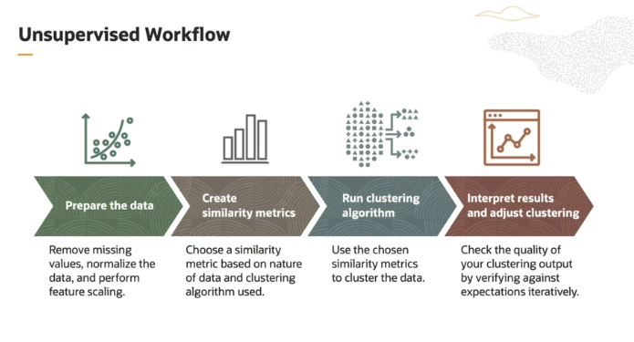

the **workflow of unsupervised machine learning** for tasks like clustering into four main steps. Let’s go through them in an easy way:

**1. Prepare the Data**

* This is the first step where you get the data ready for analysis.
* You need to **clean the data** by removing missing values (empty or incorrect data points).
* You also **normalize the data** and **scale features** to ensure all data points are on the same scale. For example, if you're clustering fruits, you'll want to scale size, color, and other features to be comparable.

**2. Create Similarity Metrics**

* This step is about choosing **how you measure similarity** between data points.
* The **similarity metric** you use depends on the type of data and the clustering method. For example:
  + **Euclidean distance**: Measures straight-line distance between points, used for numeric data.
  + **Manhattan distance**: Measures distance when you can only move in right angles, useful in some grid-based problems.
  + **Cosine similarity**: Measures how similar the **angles** between data points are, commonly used for text data.
  + **Jaccard similarity**: Measures similarity between sets, used for things like binary data (e.g., "yes/no" features).

**3. Run the Clustering Algorithm**

* In this step, the algorithm uses the **similarity metrics** to actually group the data into clusters.
* There are several types of clustering algorithms:
  + **Partition-based**: Divides data into fixed groups (e.g., k-means clustering).
  + **Hierarchical-based**: Groups data into a tree of clusters (e.g., hierarchical clustering).
  + **Density-based**: Groups based on areas of high data density (e.g., DBSCAN).
  + **Distribution-based**: Assumes data is generated by some underlying probability distribution (e.g., Gaussian mixture models).

**4. Interpret Results and Adjust Clustering**

* After clustering/grouping, you **evaluate/testing the quality** of your results. But since there are no predefined labels in unsupervised learning, you can’t just check if it's "right" or "wrong."
* Instead, you compare the results against your **expectations**. Does the clustering/grouping make sense? Are the items within a cluster truly similar?
* Often, this requires **adjusting and repeating** the process by going back and experimenting with the earlier steps (like changing the similarity metric or the clustering algorithm).

**Summary:**

The workflow of unsupervised learning for clustering includes preparing the data, choosing a way to measure similarities, applying a clustering algorithm, and then iteratively evaluating and adjusting the results to improve the grouping.

**Supervised Machine Learning Product Ideas:**

1. **Spam Email Classifier:**
   * A tool that identifies whether an incoming email is spam or not, based on features like subject lines, sender details, and email content. It uses labeled data to distinguish between spam and non-spam emails.
2. **Customer Churn Prediction:**
   * A system for businesses that predicts which customers are likely to leave the service based on customer behavior and usage patterns. It uses labeled data of past customers who churned or stayed to make predictions.
3. **Credit Card Fraud Detection:**
   * A product that identifies fraudulent transactions in real-time by learning from past labeled transactions (fraudulent and non-fraudulent). It classifies new transactions based on patterns learned from the past.
4. **Medical Image Diagnosis Tool:**
   * A tool that uses supervised learning to classify medical images (like X-rays or MRIs) and detect conditions like cancer, tumors, or fractures, based on labeled training data of medical images and their diagnoses.
5. **Product Recommendation System:**
   * A recommendation system for eCommerce platforms that suggests products to customers based on their past purchase history and labeled data on customer preferences (e.g., "likes," past ratings).
6. **Sentiment Analysis Tool:**
   * A tool that classifies customer reviews, social media posts, or feedback into categories like positive, negative, or neutral. It uses labeled data (where emotions or sentiments are pre-tagged) to train the model.
7. **Voice Command Assistant:**
   * A voice assistant that can recognize and respond to user commands (like Siri or Google Assistant). It uses supervised learning by training on labeled voice data for different commands.
8. **Face Recognition for Security:**
   * A facial recognition tool that matches real-time images or videos to a database of labeled faces (e.g., employee access in a secured building).
9. **Job Application Screening Tool:**
   * A machine learning tool that screens job applicants by analyzing their resumes and cover letters, categorizing them into "qualified" or "not qualified" based on labeled data from past successful applicants.
10. **Loan Approval System:**
    * A tool that predicts whether a loan applicant will repay the loan or default, based on labeled historical data (such as applicant's financial records, employment status, and loan outcomes).

**Unsupervised Machine Learning Product Ideas:**

1. **Customer Segmentation for Marketing:**
   * A tool that groups customers into different segments based on their behaviors, preferences, and purchasing habits, without needing predefined labels. This can help in targeted marketing campaigns.
2. **Anomaly Detection in Networks:**
   * A security tool that detects unusual patterns in network traffic, helping to identify hacking attempts, intrusions, or any other irregularities without predefined labels.
3. **Product Categorization System:**
   * An unsupervised learning system for online stores that automatically groups similar products together based on attributes like description, price, or user interactions, without pre-defined categories.
4. **Market Basket Analysis (Association Rule Mining):**
   * A tool that analyzes customer transaction data to discover which products are frequently bought together (e.g., people who buy bread also buy butter). This can help optimize product placement or recommendation systems.
5. **Fraud Detection in Financial Transactions:**
   * An unsupervised learning tool that flags unusual patterns in financial transactions that don’t match normal customer behavior (e.g., unusually large purchases) without knowing what fraud looks like beforehand.
6. **Document Clustering Tool:**
   * A system that groups documents (like news articles or research papers) based on their topics, content, or keywords, helping people find related documents or information more easily.
7. **Image Compression Using Clustering:**
   * A tool that reduces the size of images by grouping similar colors or patterns together and removing redundancy, helping to compress images in an unsupervised way.
8. **Personalized Playlist Generator:**
   * A music app feature that clusters songs based on user listening habits and genres to create personalized playlists automatically, even if the app doesn’t have labeled information on song genres.
9. **Customer Behavior Outlier Detection:**
   * A tool that detects unusual customer behavior, such as unexpected purchasing patterns or account usage, helping to identify potentially fraudulent behavior without needing labeled fraud examples.
10. **Topic Modeling for Text Data:**
    * A tool that identifies hidden topics in large sets of text data (e.g., articles, books, or reviews) by clustering words and phrases without predefined labels, useful for understanding trends or popular subjects.